Table of Contents

**Chapter 01: Introduction …………………………………………………………………………………….. 2**

**Section 1.1: Background of the Organization ………………………………… 2**

**Section 1.2: Background of the Project ……….………………………………… 2**

**Section 1.3: Objectives of the Project ………….………………………………… 2**

**Section 1.4: Scope of the Project …………………………………………………… 3**

**Chapter 02: Required Analysis ………………………….………………………………………………..**

**Section 2.1: Rich Picture (Existing) ……….………...……………………………**

**Section 2.2: Six Element System Analysis (Existing) …………….………**

**Section 2.3: Process Diagram (Existing) …….....…..…………………………**

**Section 2.4: Existing Problems & Analysis ……...….…………………………**

**Section 2.5: Rich Picture (Proposed) ……...…………..………………………..**

**Section 2.6: Six Element System Analysis (Proposed)………….……….**

**Section 2.7: Process Diagram (Proposed) ……...…………………………….**

**Chapter 03: Logical System Design …………………………………………………………………...**

**Section 3.1: Business Rules …………..……….………...……………………….…**

**Section 3.2: ERD …………………..………..……….………...…………………….……**

**Section 3.3: ERD to Relations ………..……….………...…………………….……**

**Section 3.4: Normalization ..…………..……….……….....………………..………**

**Section 3.5: Data Dictionary ……..…..……….………...……………………………**

**CHAPTER 1: INTRODUCTION**

**SECTION 1.1: BACKGROUND OF THE**

**ORGANIZATION**

An Air Quality Monitoring Station (AQMS) is a system that measures metrological parameters such as wind speed, wind direction, rainfall, radiation, temperature, barometric pressure and ambient parameters. The AQMS also integrates a series of ambient analyzers to monitor the concentration of air pollutants (such as SO2, NOx, CO, O3, THC, PM, etc.) continuously. HORIBA also provides mobile monitoring stations that can be used to monitor ambient conditions at multiple sites.

**SECTION 1.2: BACKGROUND OF THE**

**PROJECT**

In this project, we propose to develop a data-driven software system for monitoring the air quality of Bangladesh. The main purpose of the proposed AQM system is to improve air quality and to establish a low-cost solution for improving AQI data.

**SECTION 1.3: OBJECTIVES OF THE**

**PROJECT**

The main objective of this project is to create an automated system which can automatically take data input provided by stakeholders and verify the data & generate charts.

Our proposed system will provide atmospheric maps and charts for monitoring the current and future Air Quality Index (AQI) of any area. The overall air quality and other pollutant data will be calculated and displayed in the form of atmospheric maps and charts which will help the decision-makers to analyze air quality and to take initiatives for improving the air quality.

In our proposed system user interfaces will be available so that users can observe the data with respect to different times.

**SECTION 1.4: SCOPE OF THE PROJECT**

To ensure a project's success, the scope of the project must be defined. We must ensure that the proposed system is much more efficient.

We are working to improve some of the below primary functionalities:

1. Keeping the data in a relational data base manner
2. Securing the data by restricting system access
3. Insert, update, and delete data from a database without inconsistency
4. Creating reports instantly
5. Generate charts from the given data

**CHAPTER 2: REQUIREMENT**

**ANALYSIS**

**SECTION 2.1: RICH PICTURE (EXISTING)**

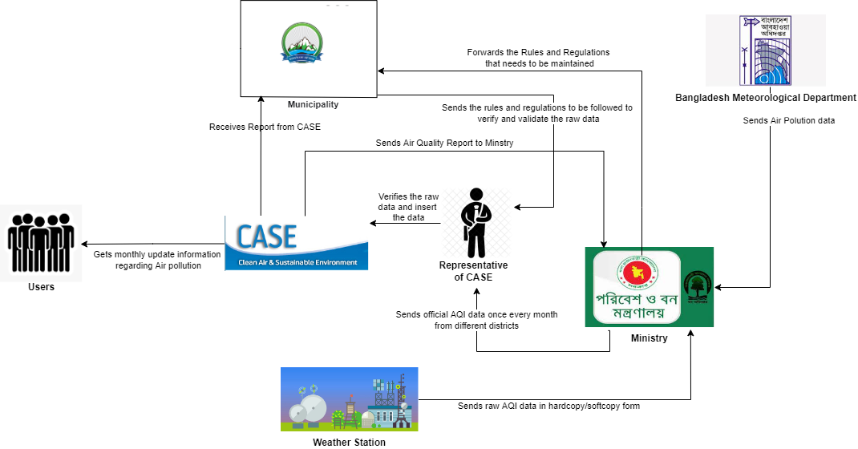

**SECTION 2.2: SIX ELEMENTS SYSTEM**

**ANALYSIS (EXISTING)**

|  |  |  |  |  |  |  |
| --- | --- | --- | --- | --- | --- | --- |
| **Process** | **System Roles** | | | | | |
| **Human** | **Non-Computing Hardware** | **Computing Hardware** | **Software** | **Database** | **Network & Communication** |
| **Insert AQI Data** | **Bangladesh Meteorological Department:**   1. Collects the air pollution data and sends it to the ministry.   **Weather Station:**   1. Collects AQI data from the sensors and satellites and sends these raw AQI data to the ministry in hardcopy or softcopy form.   **Ministry:**   1. Receives the air pollution data from Bangladesh meteorological department in hardcopy or softcopy form. 2. Receives the raw AQI data from the weather station which was taken from different sensors and satellites in hardcopy or softcopy form. 3. Accumulates all the AQI data of each month from the ministry and sends these AQI data to the representative of CASE in hardcopy or softcopy form once every month.   **Representative of CASE:**   1. Receives the monthly AQI data from the ministry and then inserts this data into the database of CASE.   **Internal IT Expert:**   1. The IT experts make sure the data is protected in the CASE system.      1. They must make sure the website is always running. 2. They keep a backup ready in case of power failures.   **External IT Expert:**   1. Server providers manages the network resources so that any user of the CASE system can access the system from anywhere in the world. 2. The internet service providers provides internet connection to the representative of CASE to do their data entry. | **Paper and stationery:**   1. Stationary used to update on the data sheet by the workers collecting the raw data. 2. Bangladesh meteorological department and weather station can use papers to manually send the data to the ministry. 3. Ministry can use paper for printing purpose to keep a manual database. 4. Ministry can use paper to manually send the data to the representative of CASE.   **Data Sheet in Printed Version:**   1. The data sheet can be used by Bangladesh meteorological department and weather station to collect the data from the satellite and sensors.   **Cabinets:**   1. Cabinets used to store the Register Books or Data sheets prepared by the Data sourcing departments and the ministry.   **File Holder:**   1. To hold the data sheet prepared by the Bangladesh meteorological department and weather stations. | **PC/ Laptop/ Other computing device:**   1. Computers, mouse, keyboards and any other computing devices are used by all the users of CASE in order to input and select data.   **Printer:**   1. Printers are used by all the users in order to print the AQI data sheet.   **Servers:**   1. Database servers used by CASE for the representative of CASE for data entries.   **Router/ Internet Cables by ISP Providers/ Switch**:   1. From networking side, internet cables by the ISP providers or router or switch used by the users of CASE.   **Pen drive:**   1. This is used as another medium by the users of CASE to pass the data. | **CASE:**   1. It is an interface which stores data and is used by the users of CASE for data entries.   **Operating System:**   1. Any Operating system can be used by the representative of CASE like Windows, Mac or Linux.   **Application Software:**   1. Application software used by Bangladesh meteorological department, ministry and weather station like MS Excel, MS Word.   **Web Based Application Software:**   1. Bangladesh meteorological department and weather station may use application software to collect data from sources.   **Printing Software:**   1. To print the data sheets, a printing software is needed by Bangladesh meteorological department, weather station and ministry. | **MySQL**:   1. The representative of CASE can also use database system like MySQL to store the raw data.   **MS Excel Files:**   1. Data can be stored in MS Excel files.   **Register Book or Log Files:**   1. Bangladesh Meteorological department, weather station and ministry can use register book or log files in order to manually store data.   **Database System of CASE:**   1. Representative of CASE can use the database system of CASE in order to input and update data. | **Internet:**   1. Internet is required in order to input or update the data by the representative of CASE in the database of CASE.   **Mails:**   1. Mails can be exchanged among the users of CASE in order to communicate about the data entries. |
| **Verification & validation of Data** | **Ministry:**   1. By analyzing the previous month reports, they send rules and regulation that needs to be maintained in order to get better quality air in the cities.   **Municipality:**   1. Receives the rules and regulation from the ministry that needs to be maintained. 2. Delivers the rules and regulation to the representative of CASE which needs to be followed by the representative of CASE in order to verify and validate the raw AQI data.   **Representative of CASE:**   1. After receiving the accumulated data of the month from the ministry and the rules from the municipality, the representative of CASE verifies and validates the raw data and then inserts the data into the database of CASE.   **Internal IT Expert:**   1. The IT experts make sure the data is always protected in the CASE system. 2. They must make sure the website is always running. 3. They have a backup ready in case of power failures as well.   **External IT Expert**:   1. Server providers manages the network resources so that representative of CASE system can view, verify and update the data from anywhere in the world. 2. The internet service providers provides internet connection to the representative of CASE to view, verify and update the data entries. | **Paper and stationery:**   1. Paper can be used by the ministry and municipality to print the rules and regulations. 2. Stationery used by ministry and municipality in order to set the rules and regulations and also to sign and validate the data. 3. Representative of CASE use stationery to verify, update and validate the data by signature.   **Printed Version:**   1. Representative of CASE may print the before and after verification data sheets in order to keep a manual database.   **Cabinet:**   1. To store the data sheet before and after the verification process as a manual database.   **File Holder:**   1. To hold the data sheet after the verification process as a manual database. | **PC/ Laptop/ Other Computing Device:**   1. Representative of CASE uses computing device in order to view, verify and update the data in the database system of CASE. 2. Data can be stored in a computer as backup. 3. Municipality and ministry uses computer in order to set the rules and regulations that needs to be maintained.   **Printer:**   1. Municipality and ministry uses printer in order to print the rules and regulation in a paper and pass it forward.   **Routers/ Internet Cables by ISP Providers/ Switch:**   1. From networking side, internet cables by the ISP providers or router or switch used by the users of CASE. | **CASE:**   1. The CASE system is used by the representative of CASE to access the data provided by the data sources for reviewing. 2. It is used to input the verified data. 3. It is used to update the data if required.   **Operating System:**   1. Any operating system can be used by the representative of CASE and the policy makers like Windows, Mac and Linux.   **Web-based Application Software:**   1. The representative of CASE will use browsers to visit CASE and input data. | **MySQL**:   1. The representative of CASE can also use database system like MySQL to store the raw data after verification.   **MS Excel Files:**   1. Data can be stored after verification in MS Excel files.   **Register Book or Log Files:**   1. After verification, data can be stored in register or log files to maintain a manual database.   **Database System of CASE:**  Representative of CASE can use the database system of CASE in order to input and update data after verification. | **Internet:**   1. Internet is required in order to input or update the data after verification by the representative of CASE in the database of CASE.   **Mails:**   1. Mails can be exchanged among municipality, ministry and the representative of CASE in order to communicate about the data entries. |
| **Report Generation & Analyzing** | **Representative of CASE:**   1. From the AQI data received from the ministry every month, the representative of CASE generates reports and upload it in the database of CASE, which is shown on the website of CASE.   **Ministry:**   1. Can view and download the air pollution report from the website of CASE, which is later analyzed and new rules and regulations can be sent to the Municipality which needs to be maintained.   **Municipality:**   1. Can view and download the monthly report from the website of CASE and then analyze those reports for further new plans.   **User:**   1. Can view and download the report from the website of CASE and get information about the country’s air quality.   **Internal IT Expert:**   1. Creates the report template creating and editing module in the CASE system for the representative of CASE, so that they can create and edit templates if required. 2. Maintains the CASE system so that if there is any problem they can fix that.   **External IT Expert:**   1. Server providers in the CASE system manages network resources so that the data can be viewed, report can be generated and uploaded by the representative of CASE. 2. The internet service providers provide internet connection to municipality, ministry and the representative of CASE in order to make new policies after analyzing the report and to upload the reports generated. | **Paper and stationery:**   1. Paper can be used by the ministry, municipality and user to print the generated report from CASE. 2. Stationery is used by ministry and municipality in order to analyze the report and make new set of rules and regulations.   **Printed Version:**   1. Ministry, municipality and user may download and print the reports to analyze.   **Cabinet:**   1. To store the monthly reports in printed version.   **File Holder:**  To hold the data sheet after the verification process as a manual database. | **PC/ Laptop/ Other Computing Device:**   1. Representative of CASE requires computing device in order to upload the generated report in the database of CASE. 2. Representative of CASE requires computing device to make changes in the template of the report, if required.   **Printer:**   1. Municipality, ministry and user uses printer in order to print the monthly reports of the areas of Bangladesh.   **Routers/ Internet Cables by ISP Providers/ Switch:**   1. From networking side, internet cables by the ISP providers or router or switch used by the users of CASE. | **CASE:**   1. It is used to upload the reports by the representative of CASE. 2. It is used by ministry, municipality and user to download and analyze the reports.   **Operating System:**   1. Any operating system can be used by the representative of CASE, the policy makers and users like Windows, Mac and Linux.   **Web-based Application Software:**   1. The representative of CASE will use browsers to visit CASE and input data.   **Application Software:**   1. The graphs in the report are generated using MS Excel by the representative of CASE. 2. The report template are created in MS Word. | **MySQL**:   1. The representative of CASE can also use database system like MySQL to store the monthly reports after generating those.   **Database System of CASE:**   1. Representative of CASE can use the database system of CASE in order to upload the reports.   **HDD:**   1. The downloaded reports can be stored in a hard disk for backup. | **Internet:**   1. Internet is required in order to upload reports by the representative of CASE in the database of CASE. 2. Internet is required in order to access the website of CASE to view or download the monthly AQI reports.   **Mails:**   1. Mails can be exchanged among municipality, ministry and the representative of CASE in order to communicate during the analyzing of the reports. |

**SECTION 2.3: PROCESS DIAGRAM**

**(EXISTING)**

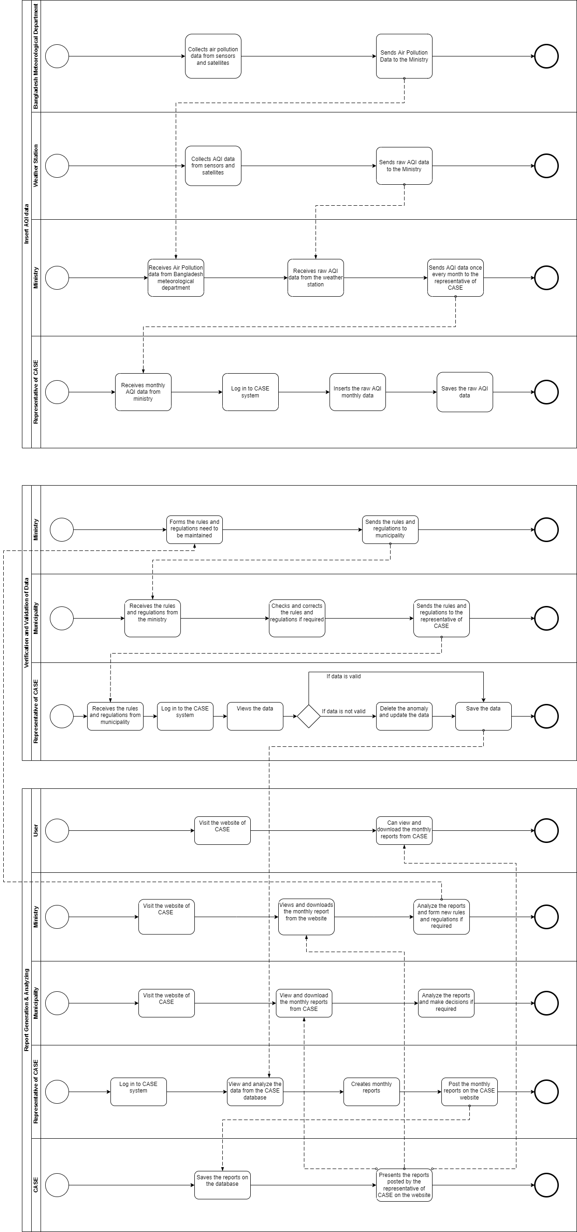

**SECTION 2.4: EXISTING PROBLEMS &**

**ANALYSIS OF THE PROBLEM**

|  |  |  |  |  |
| --- | --- | --- | --- | --- |
| **Process Name** | **Stakeholders** | **Concerns**  **(Issues/Problems)** | **Analysis**  **(Reason of the Problems)** | **Proposed Solution** |
| **Data Entry** | **1.Representative of CASE**  **2.Data providers (BMD, Ministry, Weather Station)** | 1.Takes longer time to gather data(s) | 1.As data is collected from different sources and there are huge number of data to process to it becomes very time consuming | 1.Re-build the database in a way so that the stakeholders can input their own data directly and generate reports. It will help stakeholders to input and access data easily. Thus, it’ll decrease data entry delay. |
| **Verifying data** | **1.Representative of CASE** | 1.Manual checking  2.No verification and validity of data | 1.All the data is checked manually and it becomes very time consuming | 1.Build an in-built module that will check the input data from stakeholders, which will eliminate manual checking. |

**SECTION 2.5: RICH PICTURE (PROPOSED)**

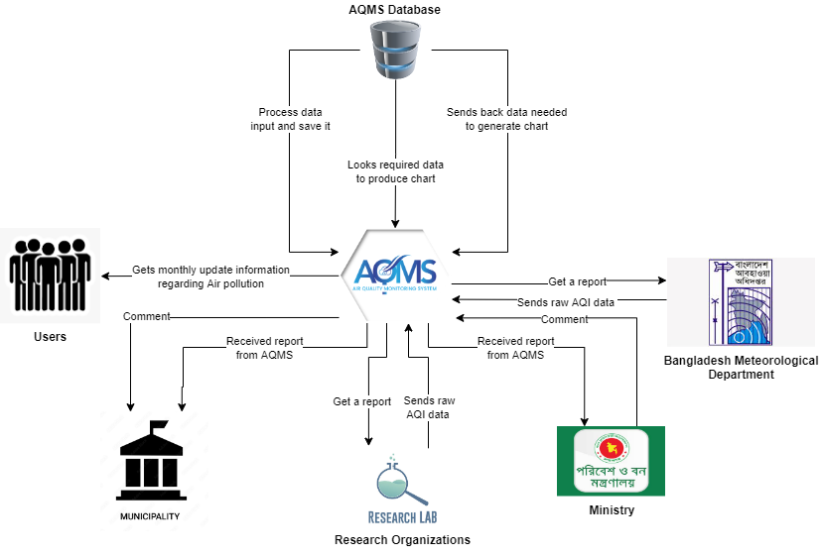

**SECTION 2.6: SIX ELEMENT SYSTEM**

**ANALYSIS (PROPOSED)**

|  |  |  |  |  |  |  |
| --- | --- | --- | --- | --- | --- | --- |
| **Process** | **System Roles** | | | | | |
| **Human** | **Non-Computing Hardware** | **Computing Hardware** | **Software** | **Database** | **Network & Communication** |
| **Data Insertion** | **AQMS:**  1.Rceives raw data from research lab.  2.Collects raw AQI data from BMD.  3.Receives comment from Municipality and Ministry.  4.Receives generated chart from the database.  **Research Lab:**  1.Collects report from AQMS.  **Ministry:**  1.Receives report from AQMS.  **Bangladesh Meteorological Department:**  1.Receives report from AQMS.  **Municipality:**  1.Receives final report from AQMS.  **Representative of AQMS:**  Receives the monthly AQI data from the ministry and then inserts this data into the database of AQMS. | **Pen and Papers:**   1. To   Collect manual data for the hardcopy.  2. Stationary used to update on the data sheet by the workers collecting  the raw data.  **PDF:**  1. The data report  can be viewed on a  PDF format.  **Data Sheet in Printed Version:**  1. The data sheet can be collected as  a printed version from the data sources. | **Computer:**   1. All   the data are finally stored using a computer.  **Smartphone:**  1.AQMS  can be accessed through any smartphone.  **Printer**  1. Printers used  to print the data  sheet.  **Scanner**  1. Scanners to  scan the data.  **Router/**  **Internet Cables**  **by ISP**  **Providers/**  **Switch** | **Operating**  **System:**  1. Any Operating System used  like Mac,  Windows, Linux.  **Application**  **Software:**  1. Application  software  like MS  Excel,Chrome;  Safari;  Firefox  etc**.**  **Printing**  **Software:**  To print the data sheets, a printing software is needed by Bangladesh meteorological department, weather station and ministry. | **Database System of AQMS**  **1.** Collection of data  is updated into a  database system of AQMS.  **MS Excel files:**  1. MS Excel files can  be used to store the data.  **MySQL:**  1.Database system like  MySQL to store the  raw data. | **Internet:**  1.Used to access the system.  2. Internet is  used to validate  the forms and  reports.  **Mail:**  1.Mail is used to transfer data.  **2.** Mails can be exchanged among the users of AQMS in order to communicate about the data entries. |
| **Data Analysis and Data Update** | **AQMS:**  1.Process data and send required data to regenerate the chart.  **Municipality:**  1.After analyzing the received data from AQMS, sends a comment back to AQMS.  **Research Lab:**  1.Analyze the raw data and sends a report to AQMS.  **Representative of AQMS:**  1. The AQMS representative examines and validates the raw data after receiving the tallied data for the month from the ministry and the rules from the municipality, and then enters the data into the AQMS database. | **Not Applicable** | **Computer:**   1. All   the data are finally stored using a computer.  **Smartphone:**   1. AQMS   can be accessed through any smartphone.  **Printer**  1. Printers used  to print the data  sheet.  **Scanner**  1. Scanners to  scan the data.  **Router/**  **Internet Cables**  **by ISP**  **Providers/**  **Switch** | **Operating**  **System:**  1. Any Operating System used like Mac,  Windows, Linux.  **Application**  **Software**  1. Application  software  like MS  Excel,Chrome;  Safari;  Firefox  etc**.**  **Printing**  **Software:**  To print the data sheets, a printing software is needed by Bangladesh meteorological department, weather station and ministry. | **Database System of AQMS**  **1.** Collection of data  is updated into a  database system of AQMS.  **MS Excel files:**  1. MS Excel files can  be used to store the data.  **MySQL:**  1.Database system like  MySQL to store the  raw data. | **Internet:**  1.Used to access the system.  2. Internet is  used to validate  the forms and  reports  **Mail:**  1.Mail is used to transfer data.  2. Mails can be exchanged among municipality, ministry and the representative of AQMS in order to communicate about the data entries. |
| **Output** | **User:**  1.Gets monthly updated information regarding Air pollution. | **Not Applicable** | **Smartphone:**  AQMS can be accessed through any smartphone.  **PC/ Laptop/ Computer:** AQMS can be accessed through computer. | **Operating**  **System:**  1. Any Operating System used by  the data  sourcing team  and  Users like Mac,  Windows, Linux.  **Application**  **Software:**  1. Application  software  like MS  Excel,Chrome;  Safari;  Firefox  etc**.**  **Printing**  **Software:**  To print the data sheets, a printing software is needed by Bangladesh meteorological department, weather station and ministry. | **MySQL:**  1.Database system like  MySQL to store the  raw data. | **Internet:**  1.Used to access the system.  2. Internet is  used to validate  the forms and  reports  **Mail:**  1.Mail is used to transfer data.  2. Mails can be exchanged among municipality, ministry and the representative of AQMS in order to communicate about the data entries. |

**SECTION 2.7: PROCESS DIAGRAM (PROPOSED)**

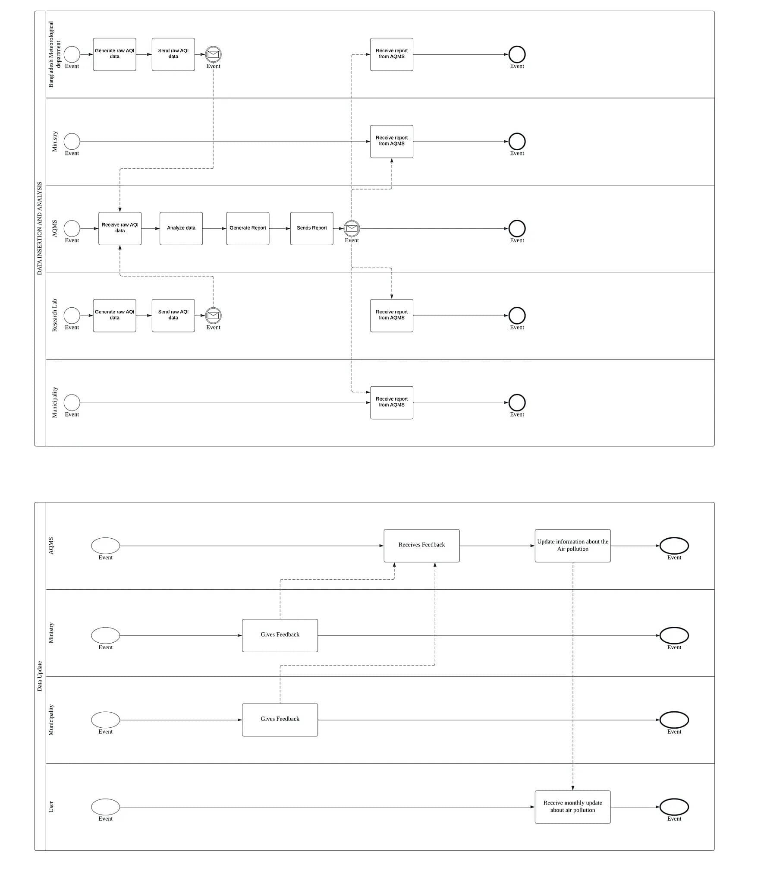

**CHAPTER 3: LOGICAL SYSTEM DESIGN**

## SECTION 3.1: BUSINESS RULES

Business rules are statements that impose some form of constraint on a specific aspect of the database, such as the elements within a field specification for a particular field or the characteristics of a given relationship. A business rule is based on the way the organization perceives and uses its data, which is determined from the manner in which the organization functions or conducts its business.

1. Municipality may view multiple policies; however, policy comments can be viewed by only one municipality. Municipality can be identified by municipality id. It also has a name, location, division, district and headquarter.

2. Policy comment has policy comment id, which user posted it and at what time it is posted, also it has comments posted by the users.

3. Ministry can be identified by Ministry id. It also has name, email & website address. Ministry can post multiple comments on policies but it will be posted by only one ministry.

4. AQMS user has user id, their name, email address & their date of birth. Also, it has their organization details and designation. AQMS users can receive multiple reports from the municipality but only one report from ministry. Reports will be received by only one user of the AQMS.

AQMS user can receive multiple AQI data from organization but will be received my only one user.

5. Organization has unique id. There are two types of organization: private research lab & metrological department.

Research lab & metrological department both has unique id(s). Research lab has location & certification. metrological department has station id and division.

6. Organization contains multiple organization data which includes: date, latitude, longitude, mean, median, max, sum, count, PM25, average temperature, rain precipitation, wind speed, visibility, cloud cover, relative humidity, division and season.

**SECTION 3.2: ERD**

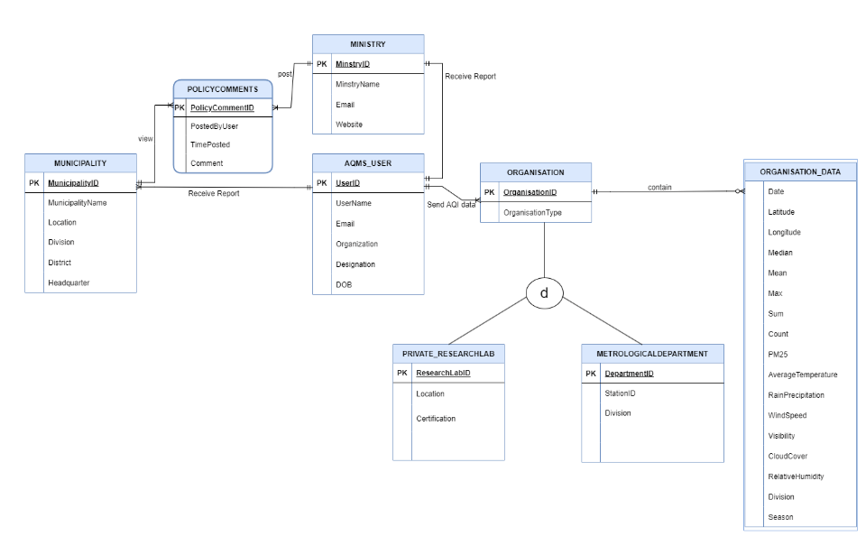

**SECTION 3.3: ERD TO RELATIONS**

**SECTION 3.4: NORMALIZATION**

**SECTION 3.5: DATA DICTIONARY**